Digital kit SILMO2021 « J » collection for spring summer 2022 :
These images can be produced either as a poster on paper or banners on canvas on request (price is based on MOQ)
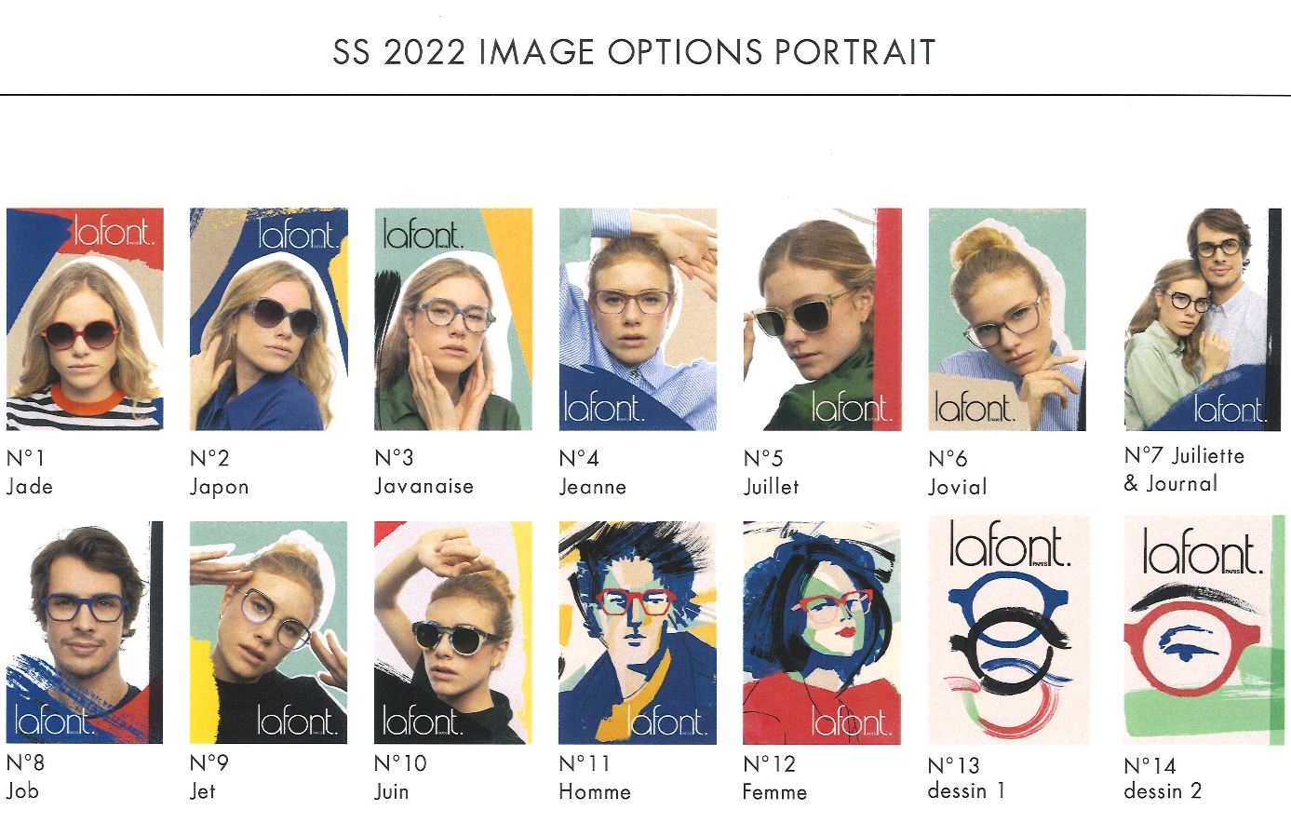
Show cards A5 format
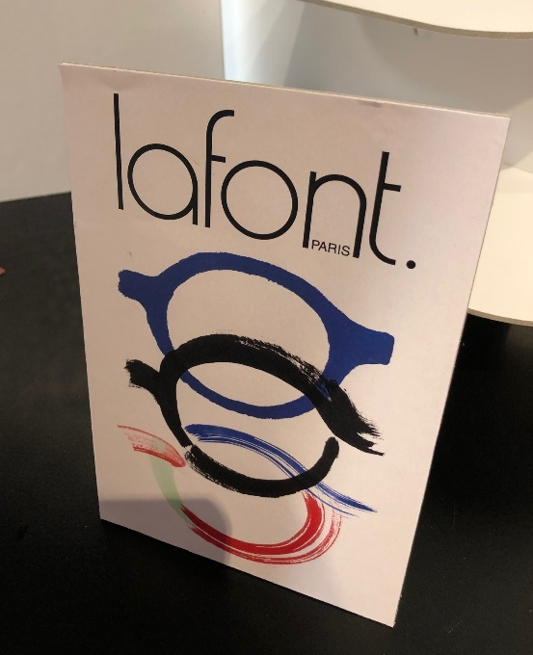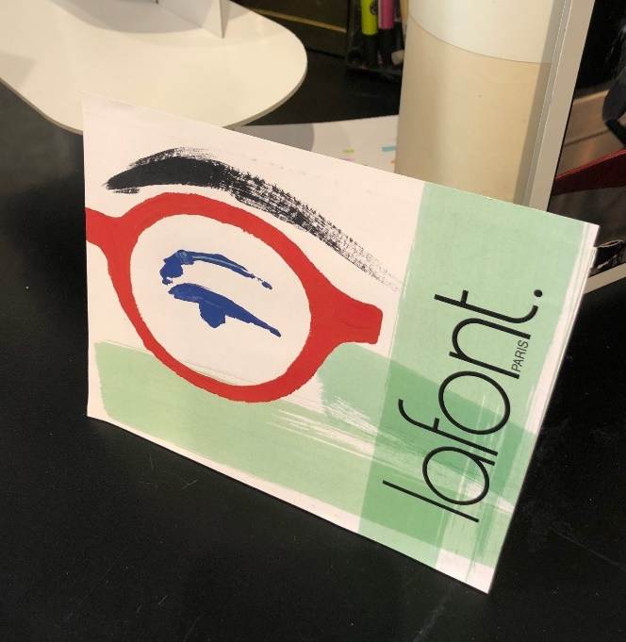

Window frames display double folding show cards
Hand made Prototype :
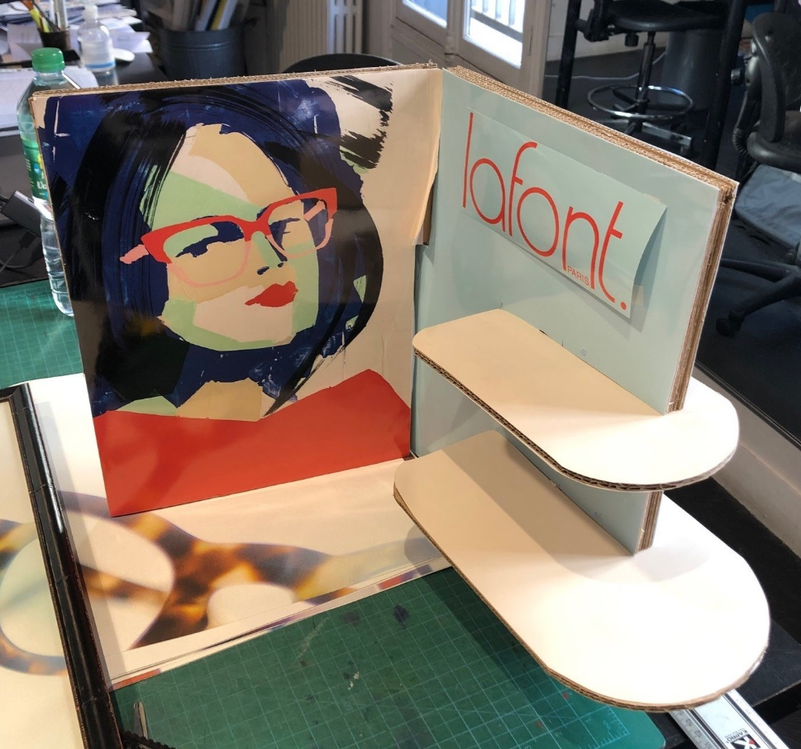
Real structure:

